SCALE DRAWINGS
Pearson Edexcel - Friday 6 November 2015 - Paper 2 (Calculator) Higher Tier
1.
Pearson Edexcel - Monday 8 June 2015 - Paper 2 (Calculator) Higher Tier
2.
Pearson Edexcel - Wednesday 5 November 2014 - Paper 1 (Non-Calculator) Higher Tier
3.
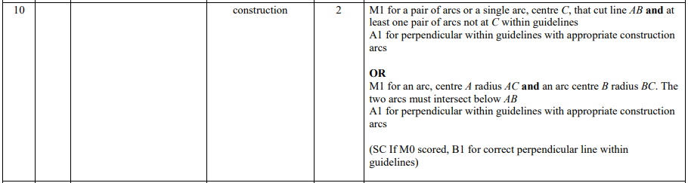
Pearson Edexcel - Monday 9 June 2014 - Paper 1 (Non-Calculator) Higher Tier
4.
Pearson Edexcel - Wednesday 6 November 2013 - Paper 1 (Non-Calculator) Higher Tier
5.
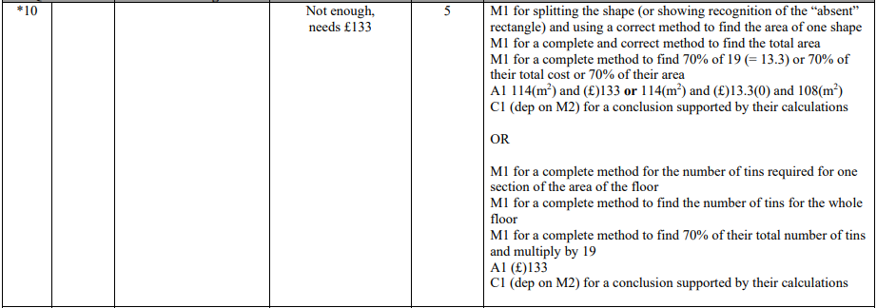
Pearson Edexcel - Tuesday 11 June 2013 - Paper 1 (Non-Calculator) Higher Tier
6.
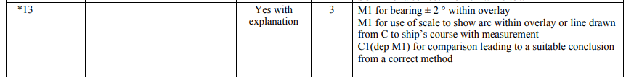
Pearson Edexcel - Thursday 28 February 2013 - Paper 1 (Non-Calculator) Higher Tier
7.
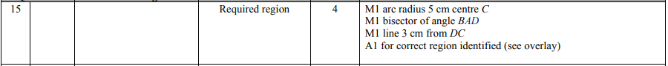
Pearson Edexcel - Tuesday 6 November 2012 - Paper 1 (Non-Calculator) Higher Tier
8.
OCR GSCE – Tuesday 5 November 2019 – Paper 6 (Calculator) Higher Tier
9.
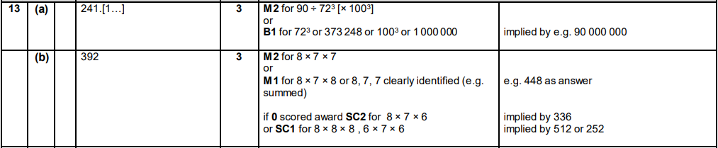

OCR GSCE – Thursday 7 November 2019 – Paper 5 (Non-Calculator) Higher Tier
10.
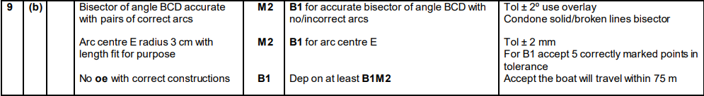
OCR GSCE – Monday 12 November 2018 – Paper 6 (Calculator) Higher Tier
11.
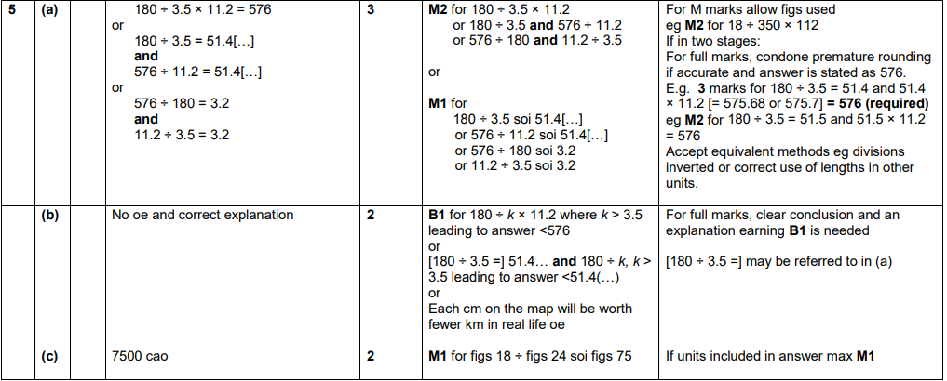
OCR GSCE – Thursday 24 May 2018 – Paper 4 (Calculator) Higher Tier
12.
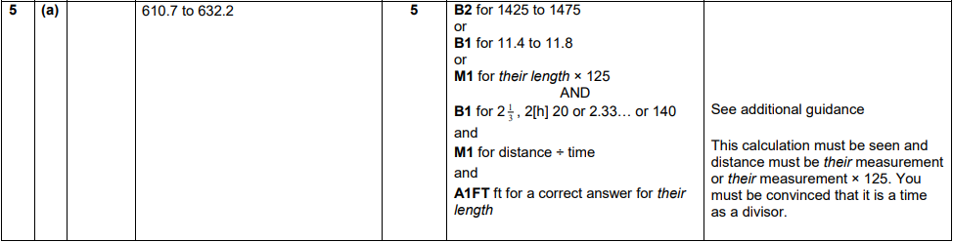

OCR GSCE – Thursday 24 May 2018 – Paper 4 (Calculator) Higher Tier
13.
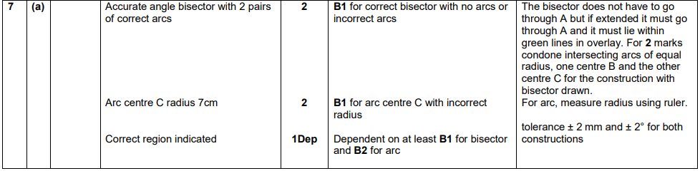
OCR GSCE – Tuesday 13 June 2017 – Paper 6 (Calculator) Higher Tier
14.
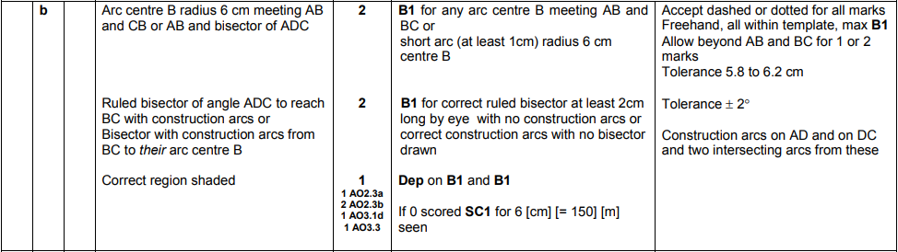
AQA GSCE – Thursday 7 June 2018 – Paper 2 (Calculator) Higher Tier
15.
